KULLIYYAH OF INFORMATION & COMMUNICATION TECHNOLOGY



SEMESTER 2, 2021/2022

SEM2 INFO 4311 DATA WAREHOUSING

SECTION 01

*TITLE:DATA WAREHOUSING FINAL ASSESMENT 1*

PREPARED BY:

|  |  |
| --- | --- |
| NAME | MATRIC NO. |
| JOYADDAR MD JOBAYER | 1731833 |

## LECTURER

LILI MARZIANA BT. ABDULLAH

#### DUE

16 JUNE 2022

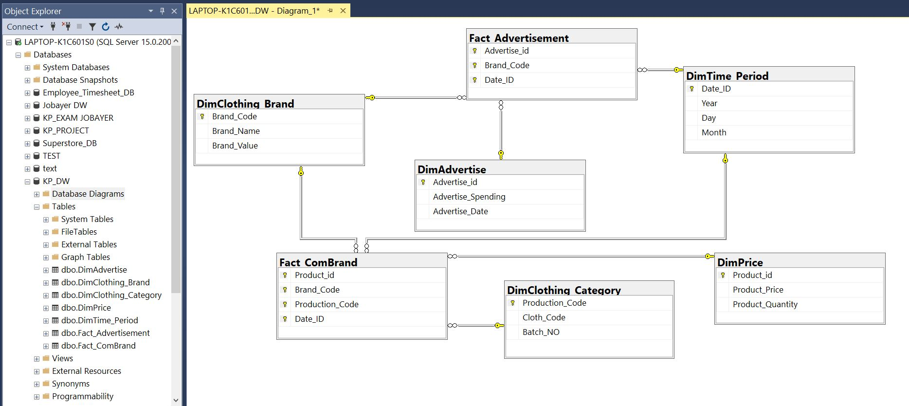

1.MULTI FACT STAR MODEL DATABASE DIAGRAM

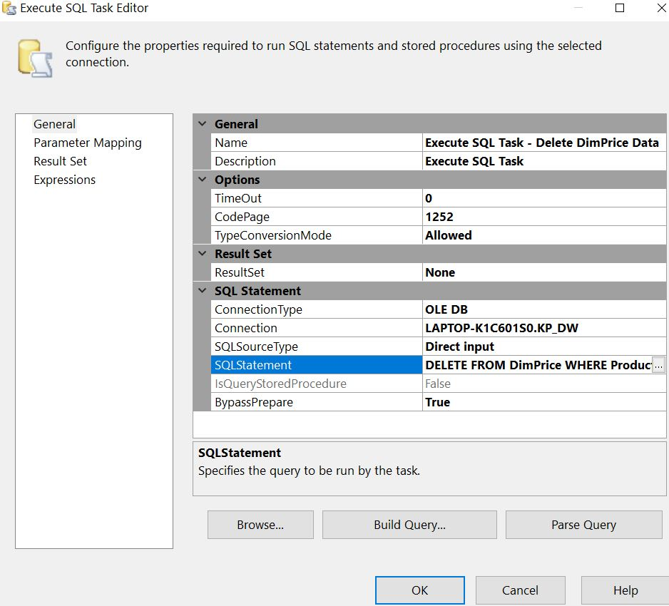

2. EXECUTE SQL TASK EDITOR

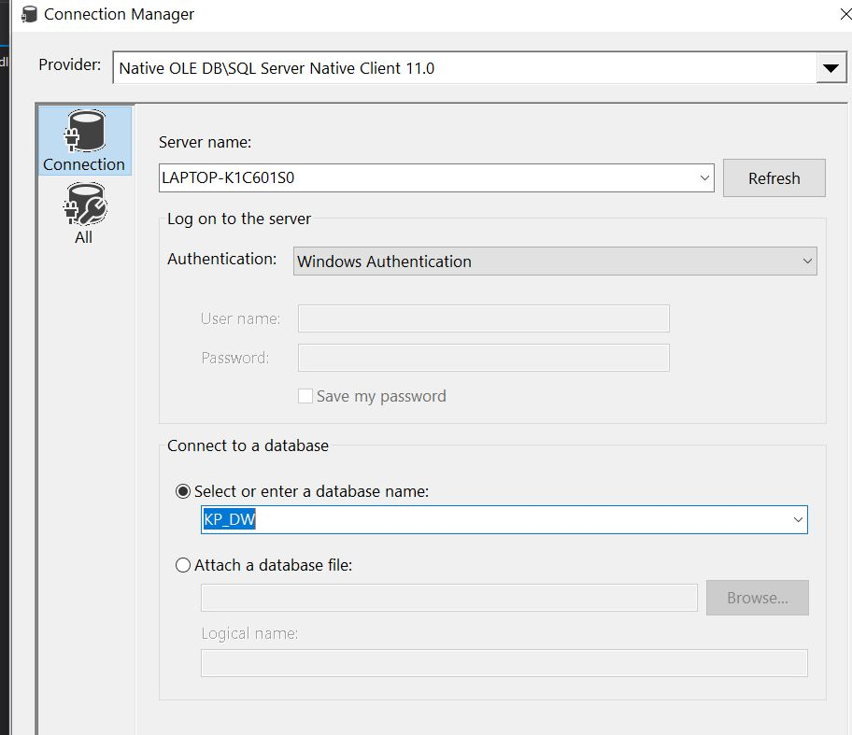

3. CONNECTION MANAGER

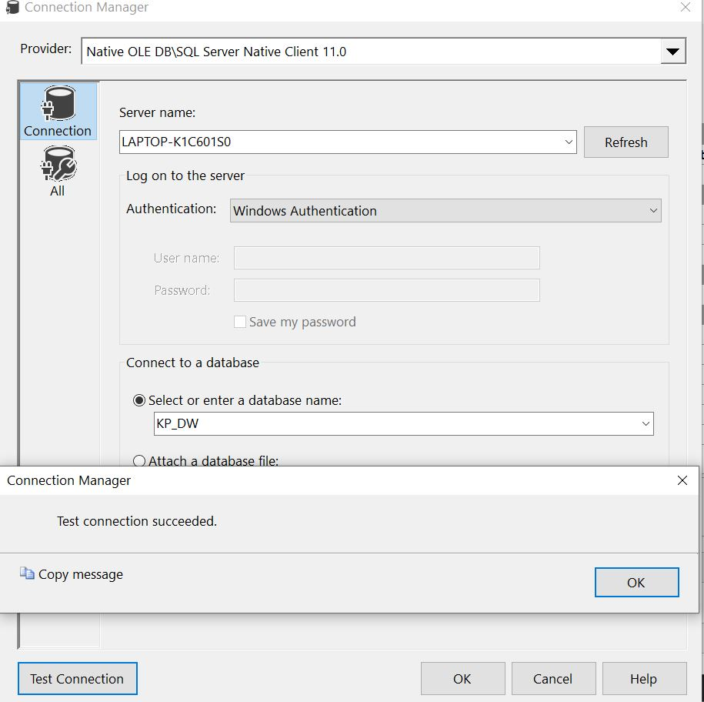

4. TEST CONNECTED PROOF

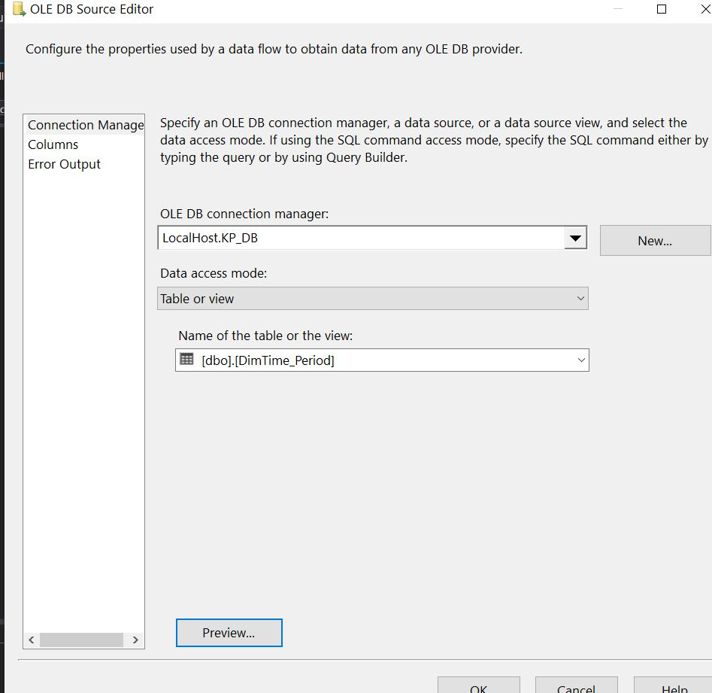

5. OLE DB SOURCE EDITOR

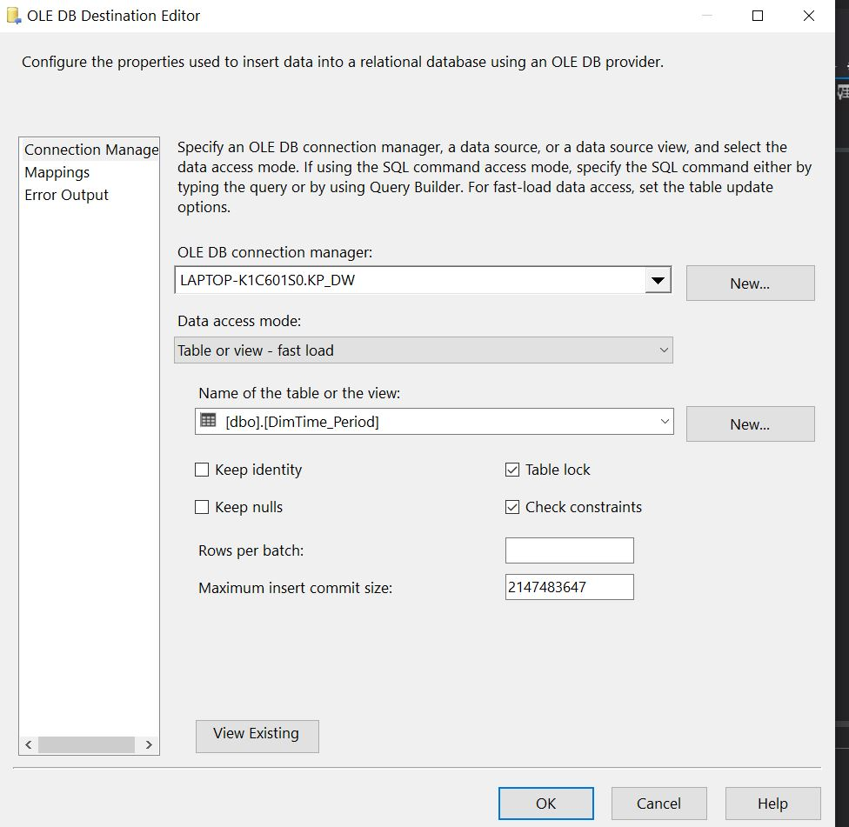

6. OLE DB DESTINATION EDITOR

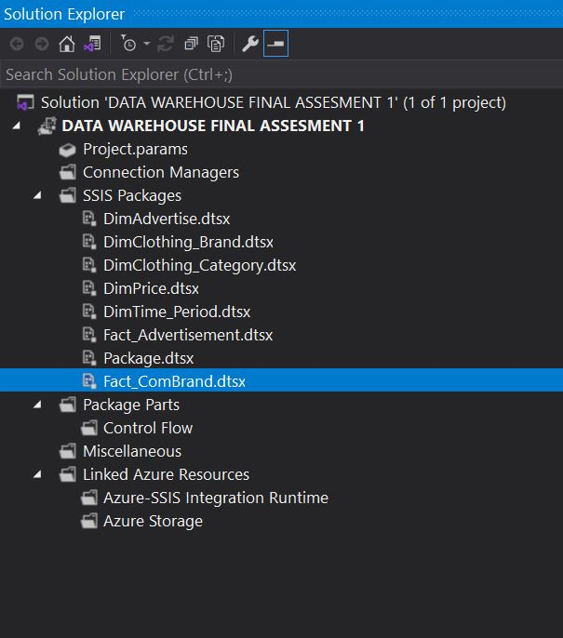

7. VISUAL STUDIO MY FILE WITH TABLES

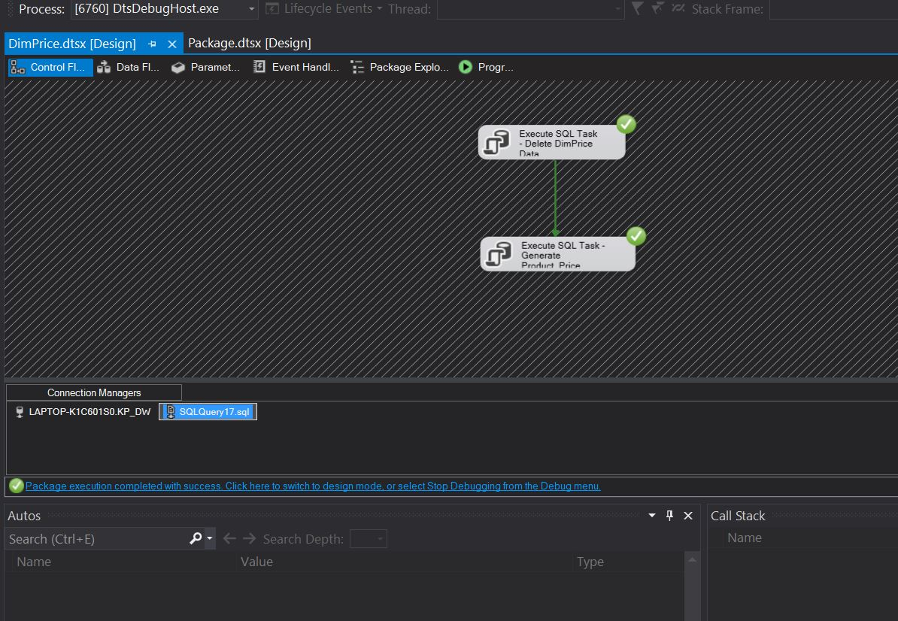

8. DIM PRICE CONTROL FLOW

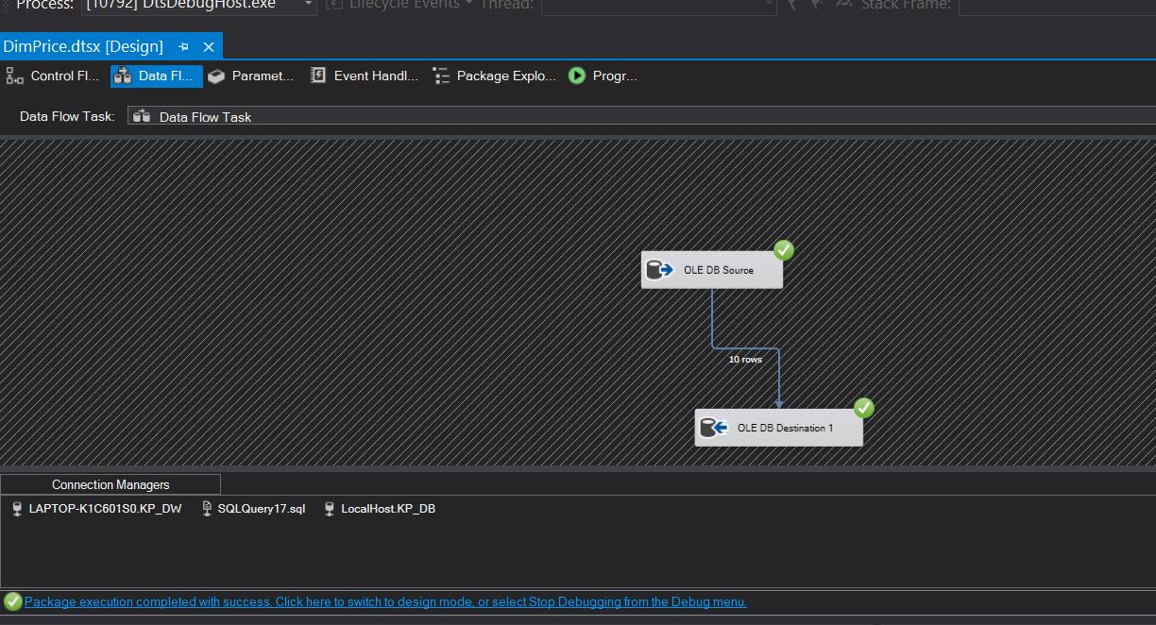

9. DIM PRICE DATA FLOW

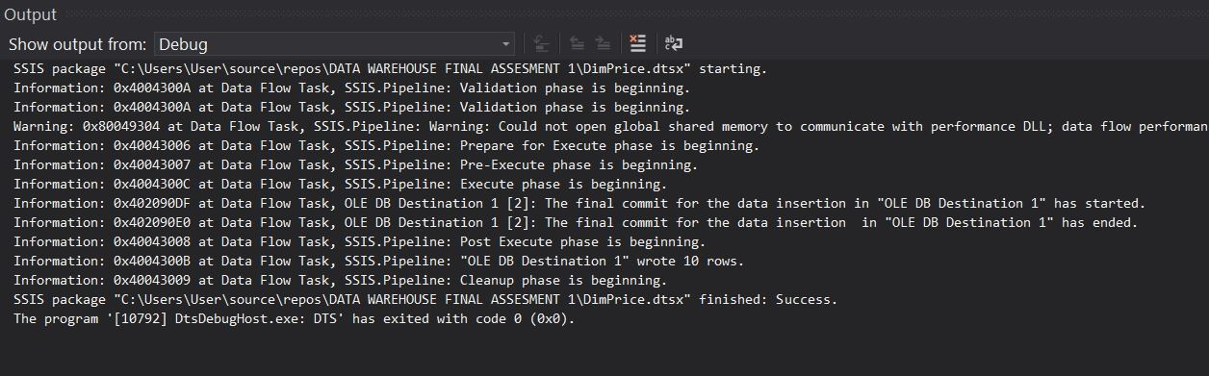

10.DIM PRICE OUTPUT

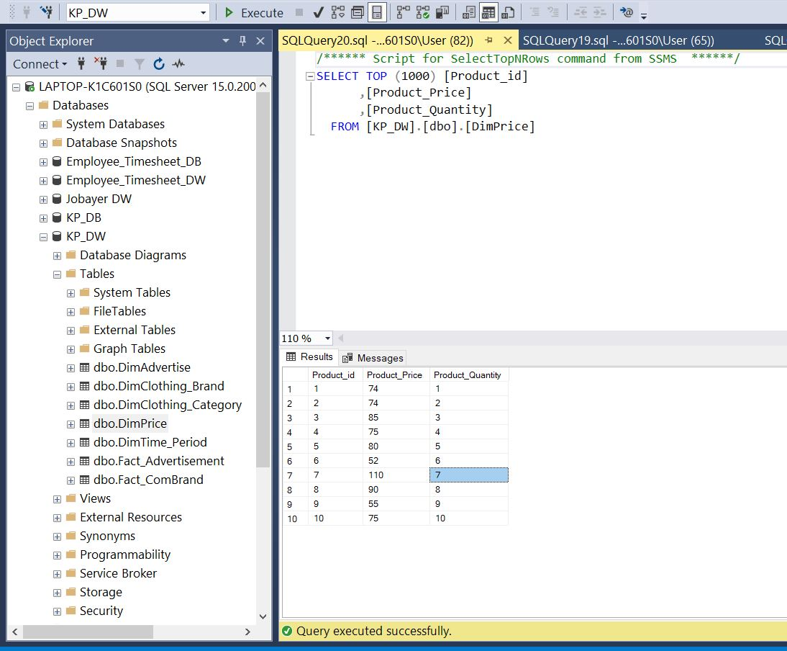

11. DIM PRICE POPULATED DATA

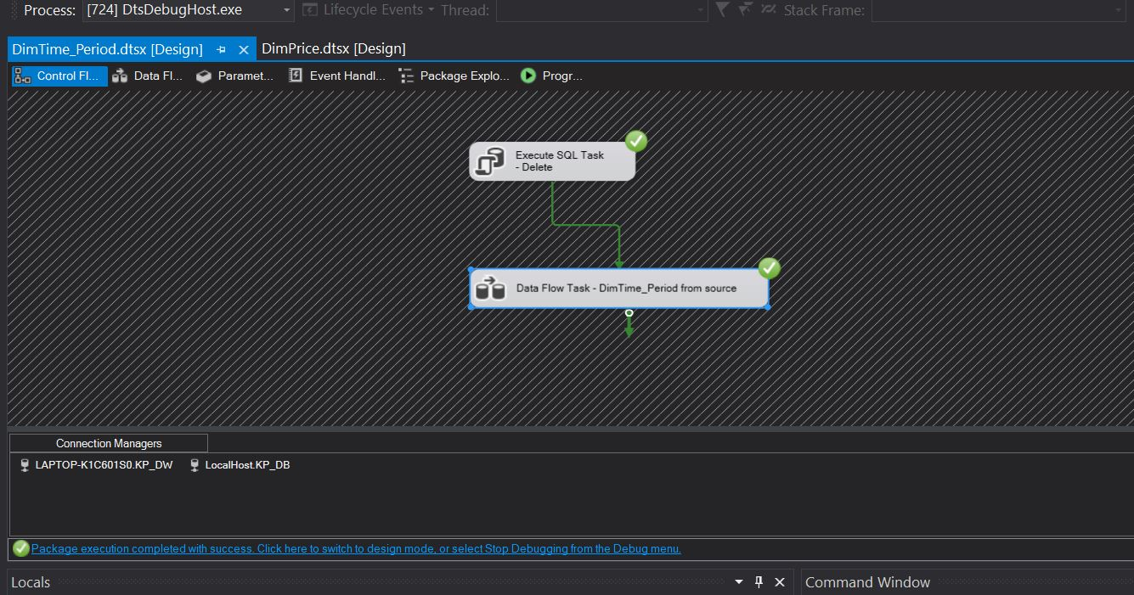

12. DIM TIME PERIOD CONTROL FLOW

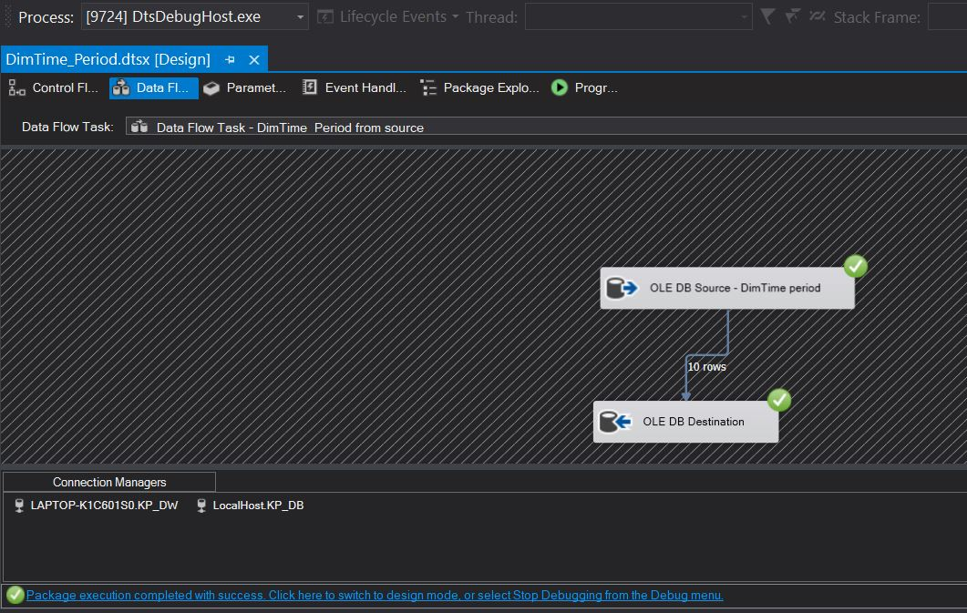

13. DIM TIME PERIOD DATA FLOW

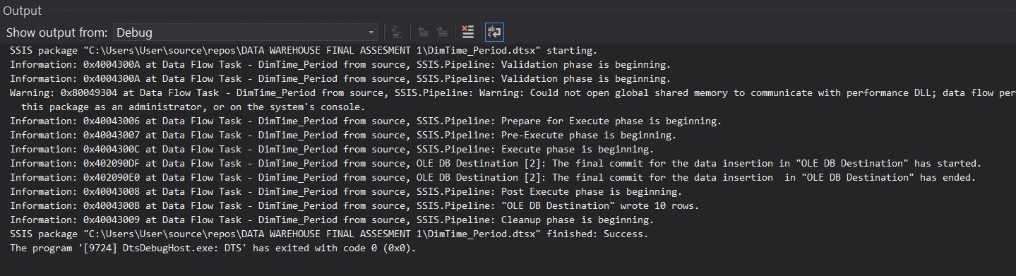

14. DIM TIME PERIOD OUTPUT

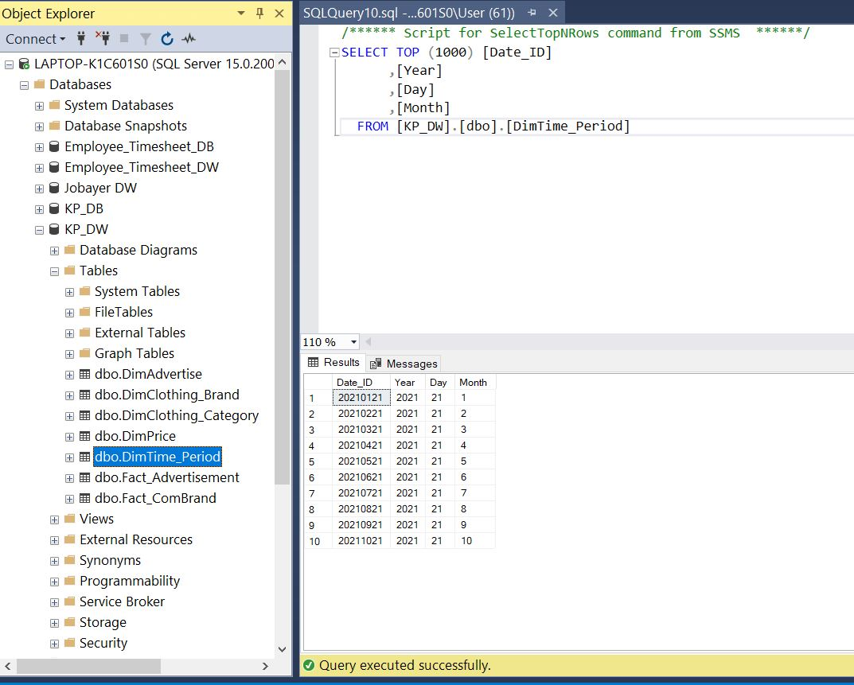

15. DIM TIME PERIOD POPULATED DATA

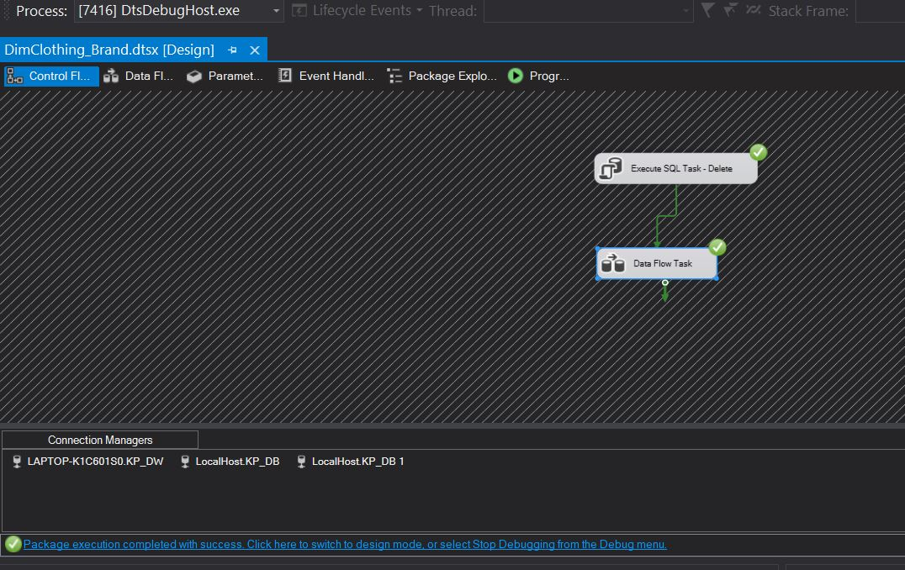

16. DIM CLOTHING BRAND CONTROL FLOW

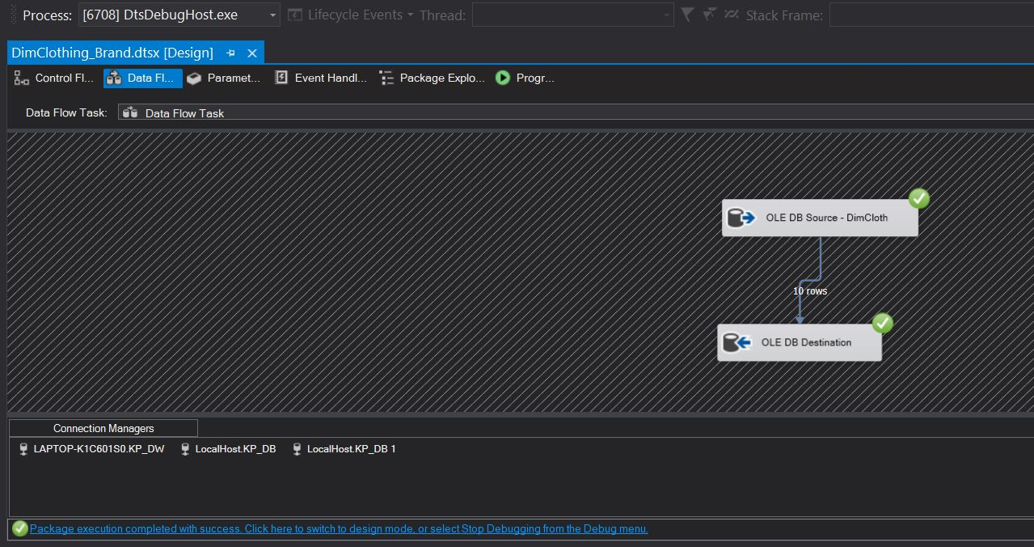

17. DIM CLOTHING BRAND DATA FLOW

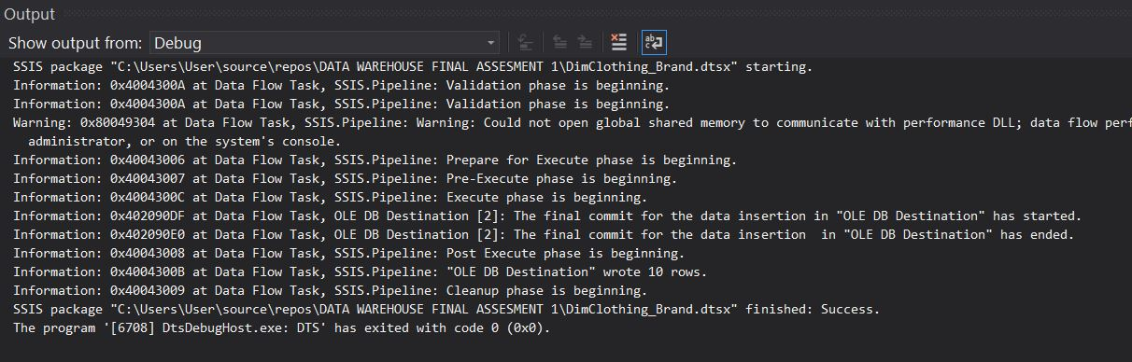

18. DIM CLOTHING BRAND OUTPUT

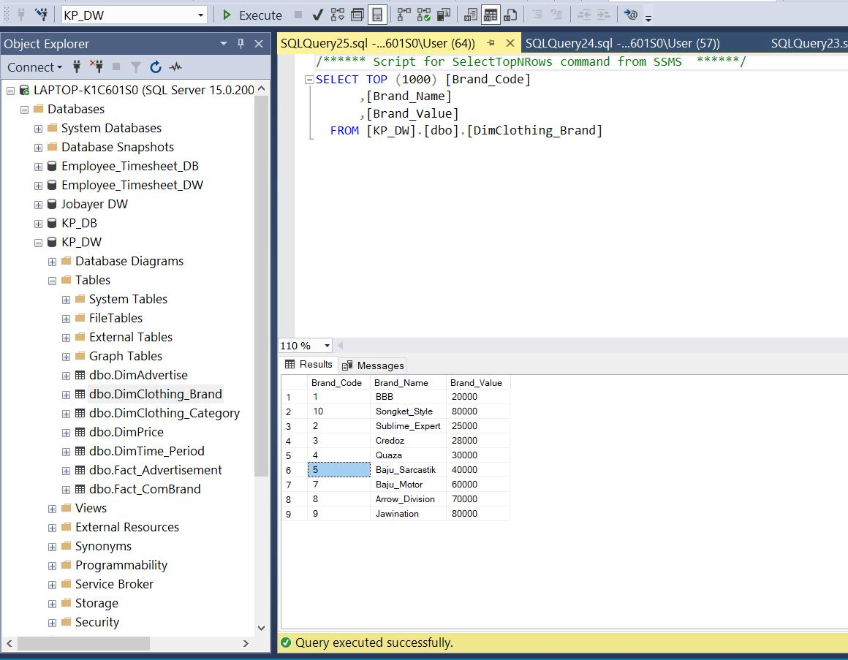

19. DIM CLOTHING BRAND POPULATED DATA

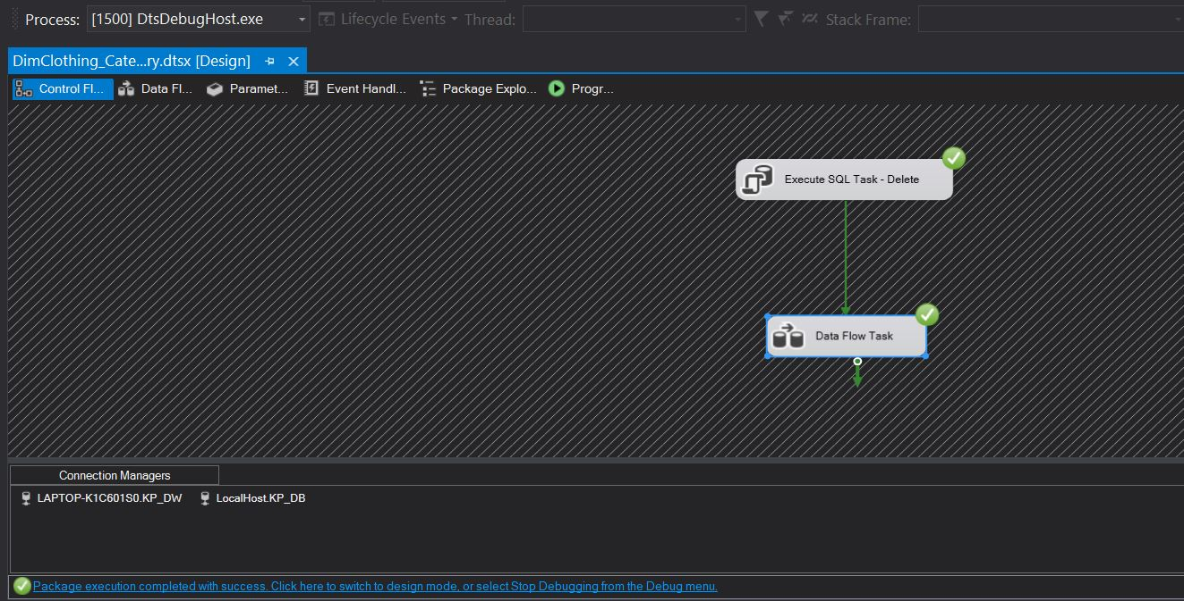

20. DIM CLOTHING CATEGORY CONTROL FLOW

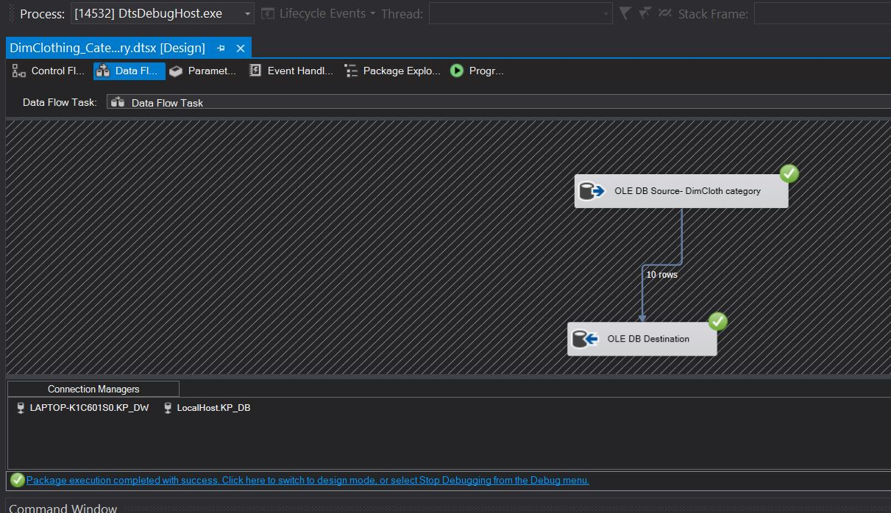

21. DIM CLOTHING CATEGORY DATA FLOW

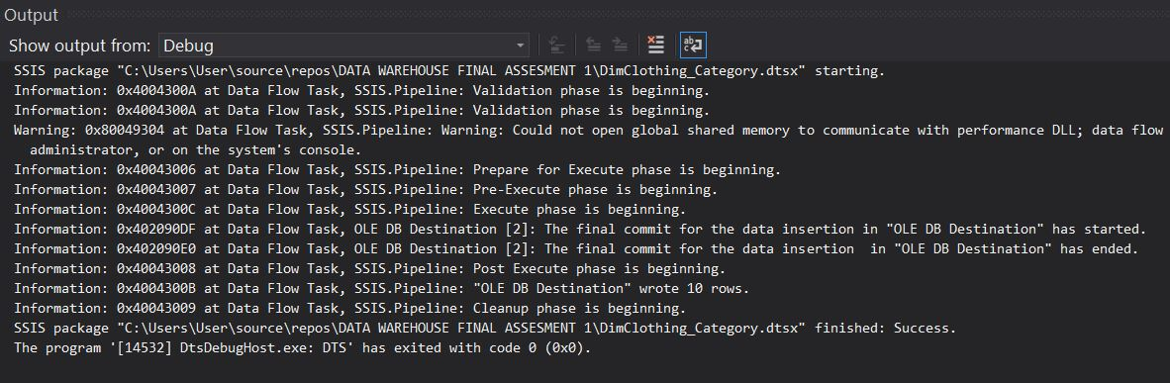

22. DIM CLOTHCATEGORY OUTPUT

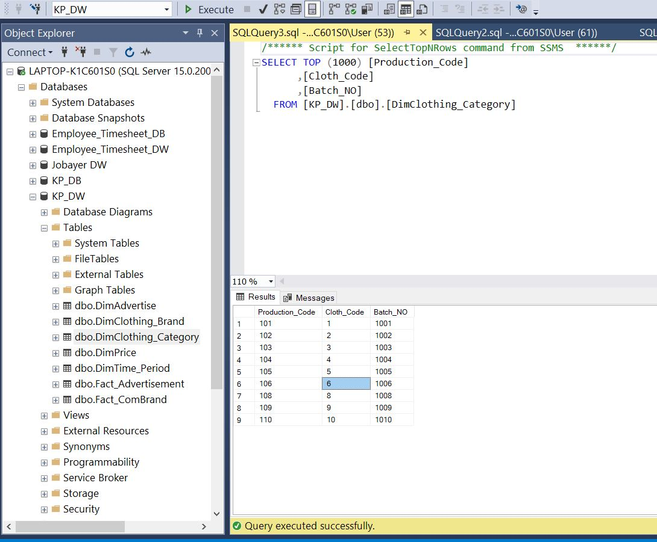

23. DIM CLOTH CATEGORY POPULATED DATA

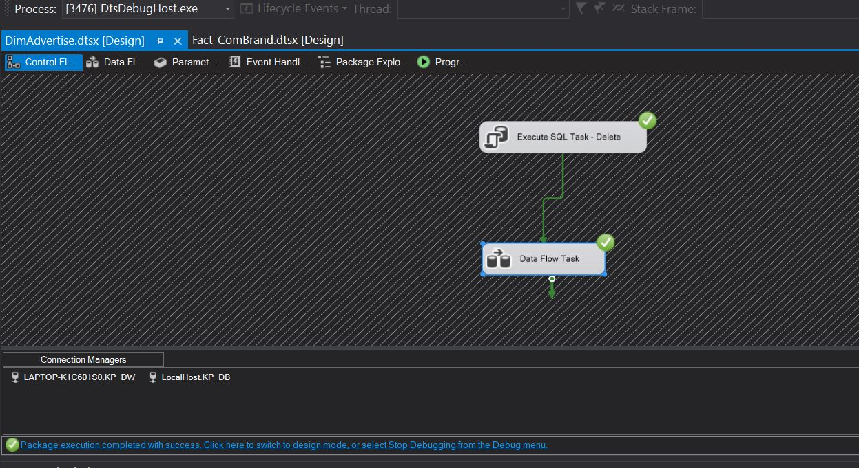

24.DIM ADVERTISE CONTROL FLOW

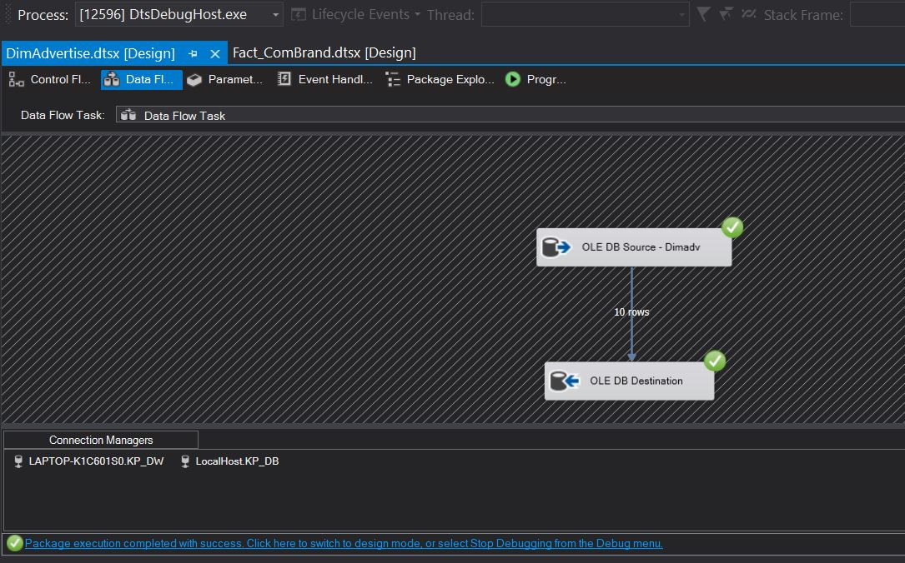

25. DIM ADVERTISE DATA FLOW

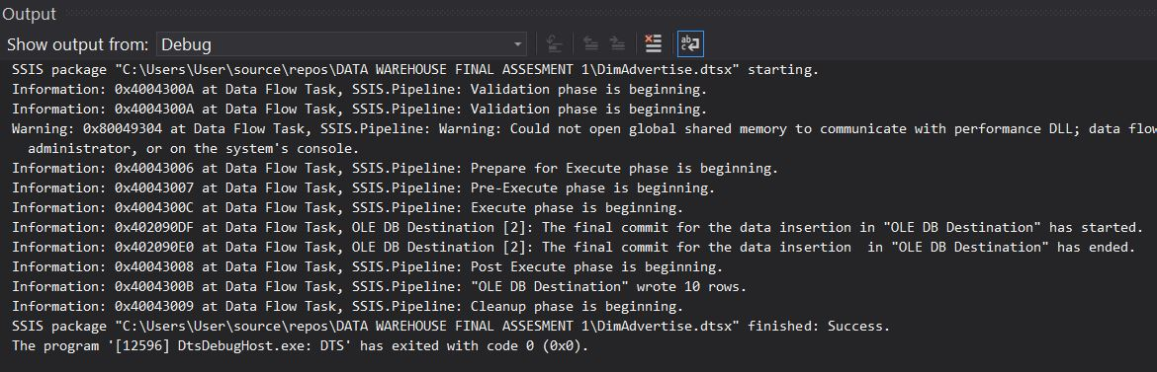

26. DIM ADVERTISE OUTPUT

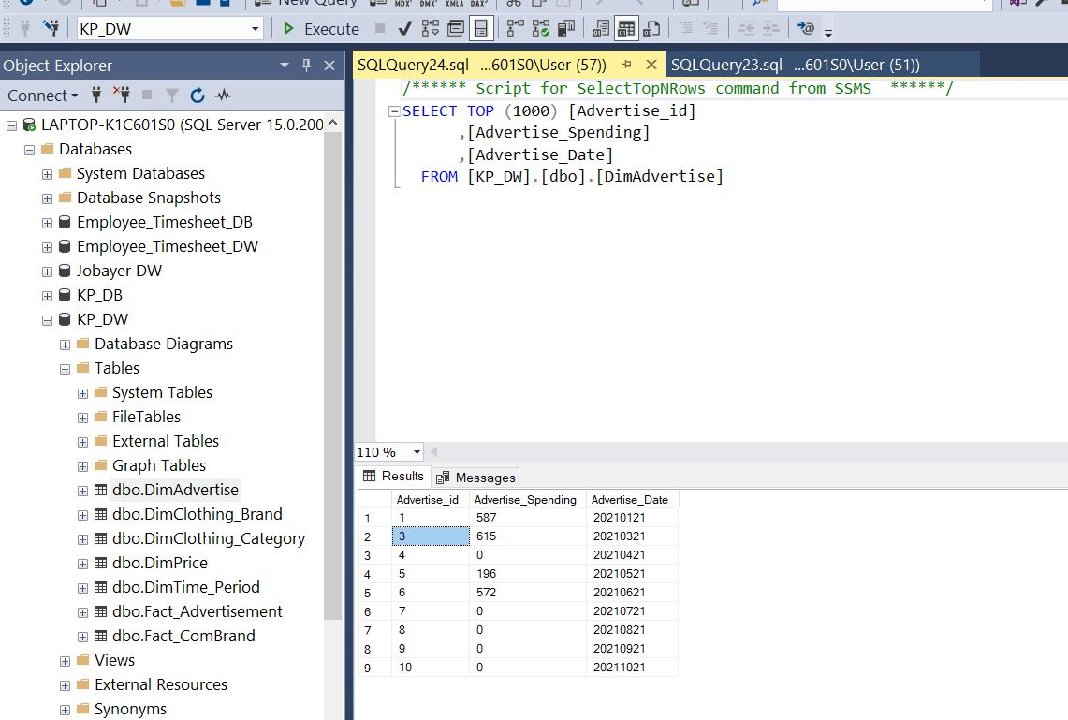

27. DIM ADVERTISE POPULATED DATA

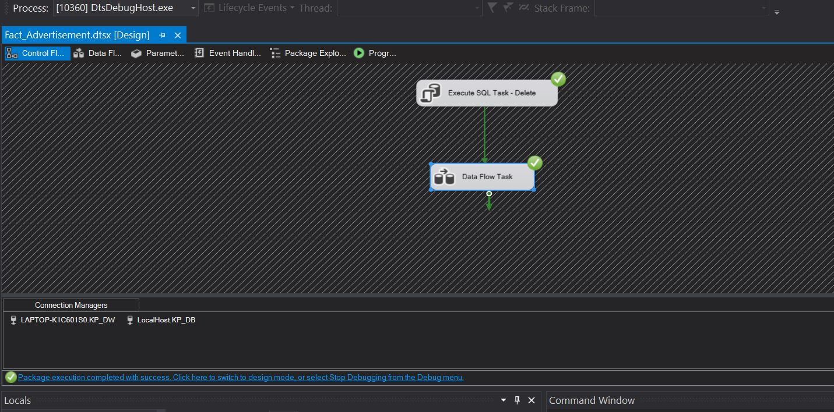

28. FACT ADVERTISE CONTROL FLOW

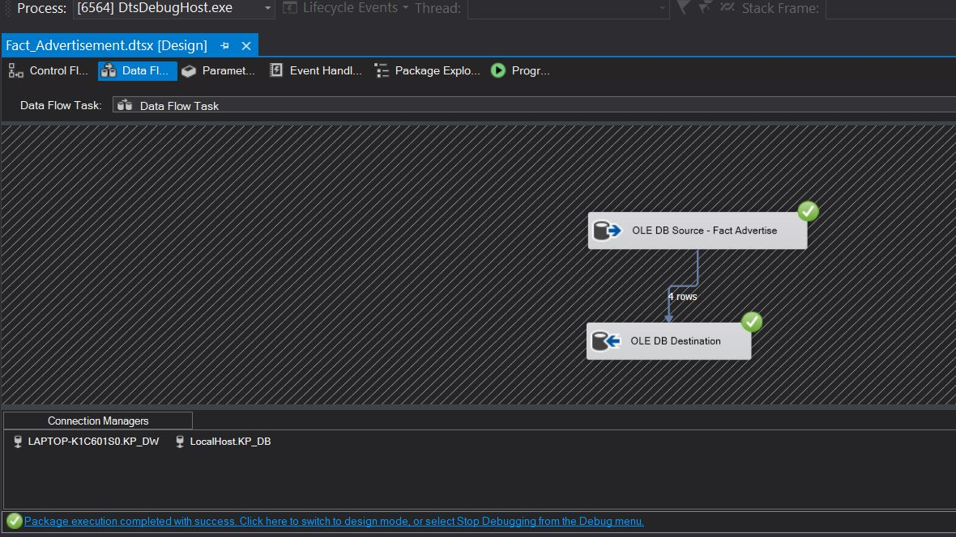

29. FACT ADVERTISE DATA FLOW

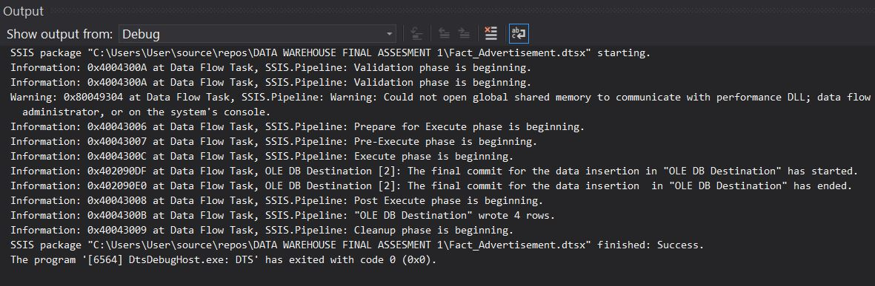

30. FACT ADVERTISE OUTPUT

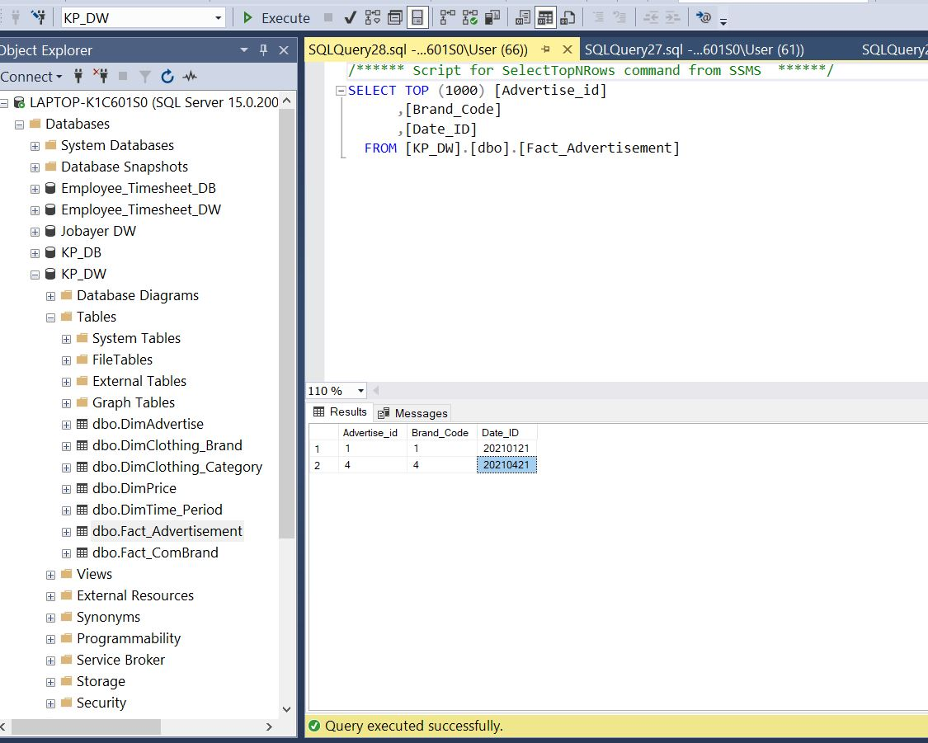

31. FACT ADVERTISE POPULATED DATA

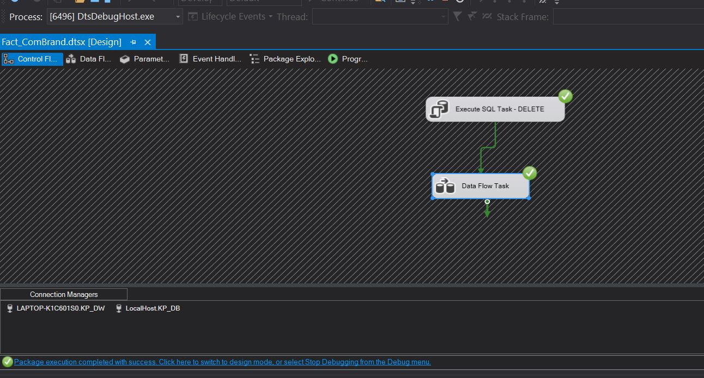

32. FACT COMBRAND CONTROL FLOW

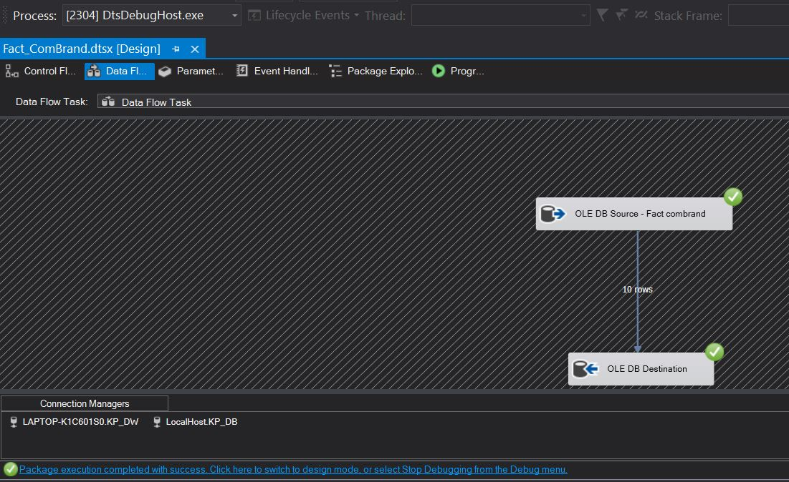

33. FACT COMBRAND DATA FLOW

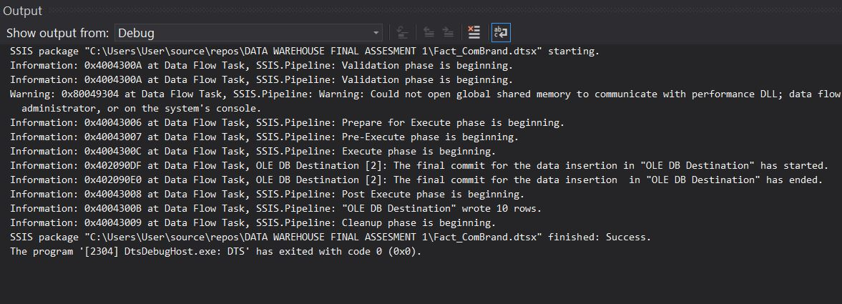

34. FACT COMBRAND OUTPUT

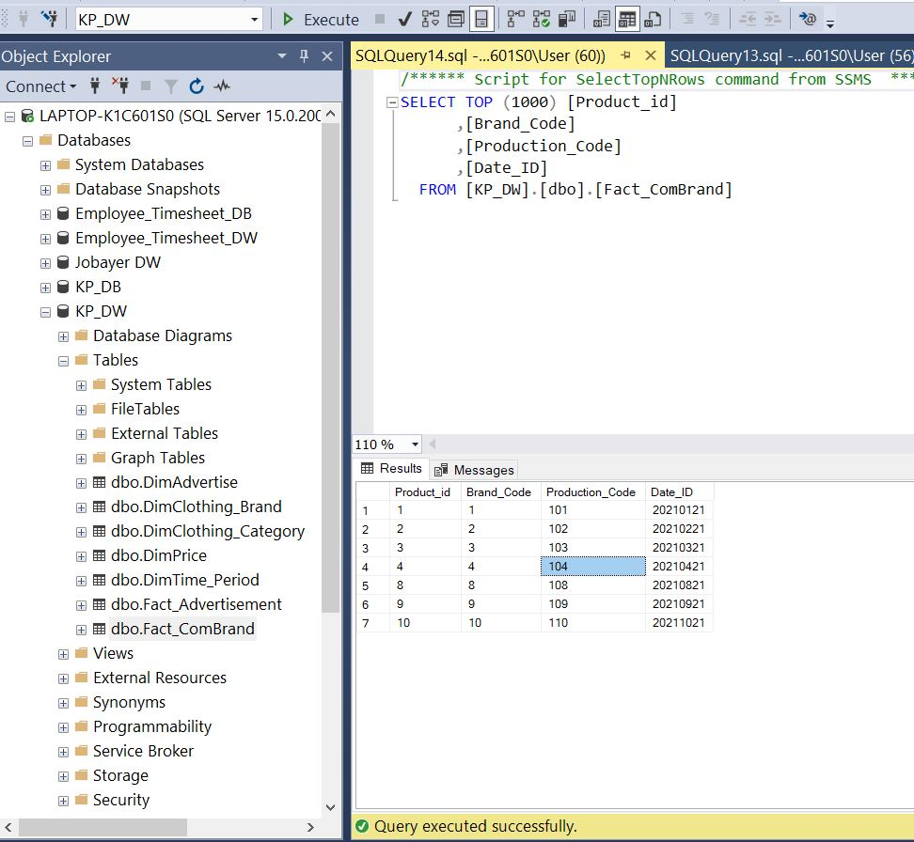

35. FACT COMBRAND POPULATED DATA